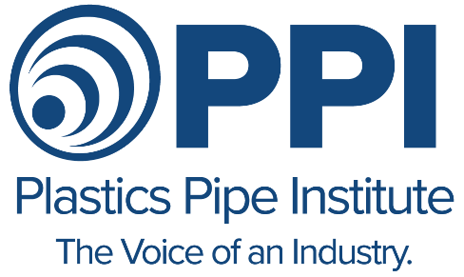
NEWS RELEASE
NY News Contact: Steve Cooper
516/623-7615
PPI News Contact: David Fink 469/499-1046

PLASTIC PIPE CHEMICAL RESISTANCE

TECHNICAL SUPPORT REPORT AVAILABLE

IRVING, Texas – August 2, 2021 – The Plastics Pipe Institute, Inc. (PPI) has a report available that details the chemical resistance capabilities for pipe made from various thermoplastic, thermoset, and composite (multi-layered) plastic materials. The technical report – Chemical Resistance of Plastic Piping Materials, TR-19 – provides information about the effects that various chemicals can have on plastic piping materials. Applications include potable water, hydronics, sanitary sewer, gas and more. It is available without charge on the PPI website. PPI is the major North American association representing the plastics pipe industry.
“Plastic pipe and fitting materials are generally resistant to attack from many chemicals,” stated David Fink, president of PPI. “This inherent property makes them suitable for use in numerous fluid and gas conveyance applications. There are, however, certain chemicals that may damage plastic pipes, either through exposure on the outside of the pipe to chemicals, on the internal surface of the pipe during the transportation of such chemicals, or with exposure to inert fluids containing chemicals in various concentrations. Each material has a unique resistance to chemicals in various situations. The suitability of a pipe or fitting system for use in a particular fluid or gas application is a function of several factors, which are detailed in TR-19.”
The free report contains sections on pipe and fitting materials, product design and joining systems, operating conditions, types of chemical attacks on plastics, and more. It applies to pipe and fitting materials such as CPVC, HDPE, PA, PE-RT, PP-R, PP-RCT, PVC, and PEX. The main table lists the chemical resistance levels of those plastics to some 600 chemicals from acetaldehyde to zinc sulfate in various concentration levels.
To obtain a copy of the report, go to: https://plasticpipe.org/pdf/tr-19-2020.pdf
# # #
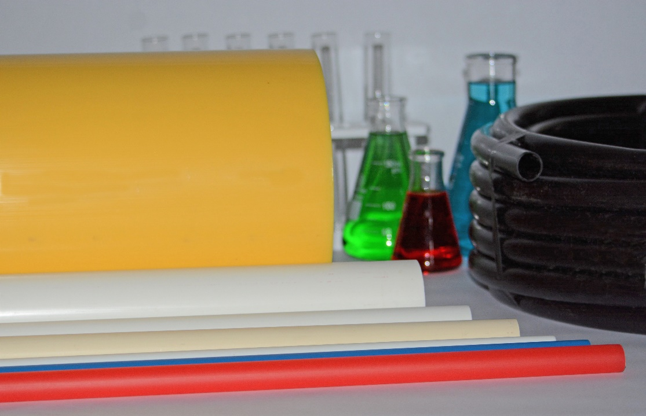
The new free report from the Plastics Pipe Institute, TR-19, lists the chemical resistance capabilities of pipe and fitting materials such as CPVC, HDPE, PA, PE-RT, PP-R, PP-RCT, PVC, and PEX.

About PPI:
The Plastics Pipe Institute, Inc. (PPI) is the major North American trade association representing the plastic pipe industry and is dedicated to promoting plastic as the materials of choice for pipe and conduit applications. PPI is the premier technical, engineering and industry knowledge resource publishing data for use in the development and design of plastic pipe and conduit systems. Additionally, PPI collaborates with industry organizations that set standards for manufacturing practices and installation methods.

